Battery Test
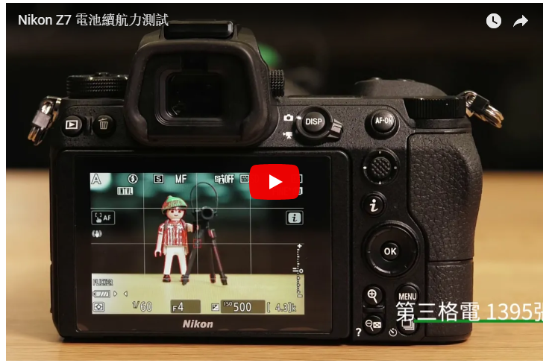
我們來看一個比較極端的環境，也是許多測到超強續航力的媒體/部落格客所得到的方式：間隔定時拍攝。
Let’s check out a rather extreme usage case, this maybe also the test case for other blog/media which is interval photo shooting.
上面影片是我以5秒為間隔，在條件皆完全固定的情況下拍攝。原本看網路上多數人的評測通常是一千張左右。我想1張5秒，所以差不多一個多小時就結束了。結果我們在原地等了3小時09分鐘，Z9總共拍了2237張照片。但這種數值真能反映實際拍攝情況嗎？我想除了縮時攝影以外都不能。
The video above is photo taken in 5 seconds interval under similar circumstances for all condition. Saw those people took around 1000 photos above for this kind of test. Therefore, if saying 1 photo in 5 second, the test should be done in around an hour. As a result, we waited for 3 hours 9 minutes for this test to complete, Z7 (Typo) took total of 2237 photos. Bear in mind, this figure does not represent the actual usage of real life, it may be only applicable to timelapse only.
其實拍過縮時的人都知道，縮時攝影的拍攝張數肯定比單次拍攝的電池續航力長。就算螢幕都是開著的，也肯定會拍比較多張。我不明白確定的原因，可能是一般使用會時常開關機、或者是對焦、使用觀景窗或各種功能等等。 就好像我前陣子測Sony A9+400mm f/2.8GM全程使用高速連拍一樣，一場球賽下來超過4000張，電池才掉一半，與CIPA的650張數據完全相左。所以極端或少數環境下測試不一定能反映一般用家的真實情況。
Actually, those who took timelapse previously should have know, the batter life is usuall longer. Even though the screen is kept constantly on, the total photos able take is more than usual. I have no idea about the reason behind, maybe the constant on/off, of focusing or using EVF and other feature may caused more drain. Just like the test before using Sony A9 + 400mm f/2.8 GM, full burst mode, I’ve managed to get 4000 shots and the battery only drop to 50%, totally incompare to CIPA results of 650 shots.
但就小編目前短暫的實拍經驗來說，官方經過CIPA認證的數據：330張，大概就是第一格電的電量。我沒有深究CIPA是怎麼去測試的，但我認為這個CIPA的數據非常背離實際使用。
Given the experience from editor, CIPA statistics of 330 shots is normally for 1 bar of battery indicator. I did not study the methodology of CIPA, but the usage may very much deviate from our daily usage.
如果要我非常保守的說，根據經驗如果你用非常浪費電的方式在使用，例如只用電子觀景窗、把省電功能關閉、不太關機，應該也可以使用500-600張左右。普通使用應該可以在800張以上。330張這種數據就把它留在官網上就好。
Conservatively, based on experience and you didn’t care much how you shoot, like using EVF, shut of power saving function, kept the camera on, then it most ly gives you around 500-600 shots. Normal usage should be 800 shots above, as for the 330 shots in the official report, just let it be.

Machine On/Off Speed
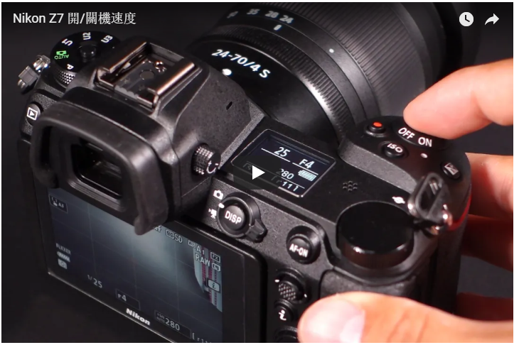
高階的數位單眼往往都會在開機速度上做文章，由於不需要液晶螢幕顯示就能拍照，所以開機可以做到超級快，通常在0.5到0.1秒之間。但無反光鏡相機沒有光學觀景窗，所以不開機就是一片黑的狀態
。光線要先進到感光元件，感光元件將訊號處理之後送到螢幕去顯示，需要花相對長的時間。我們來看看Z7的開機速度：
High end DSLR will focus on the On/Off time performance. The speed is very fast for DSLR because no LCD need to turn on, normally between 0.5 to 1 second. But mirrorless has o Optical Viewfinder, so it remain blackout without turning on. The light needs to hit the sensor, then the information transfer to screen, it may need longer time. Let see the On/Off speed in the Z7 in video.
我是撥動開機撥桿之後，直接去按快門，並且設定成MF，所以這是開機到實際可以拍攝最短的時間，大約需要1秒鐘才能完成。
I push the On dial, and press the shutter directly, the setting is MF, therefore this is the shortest possible time from on to shoot, the time required around 1 second.

Shutter sound
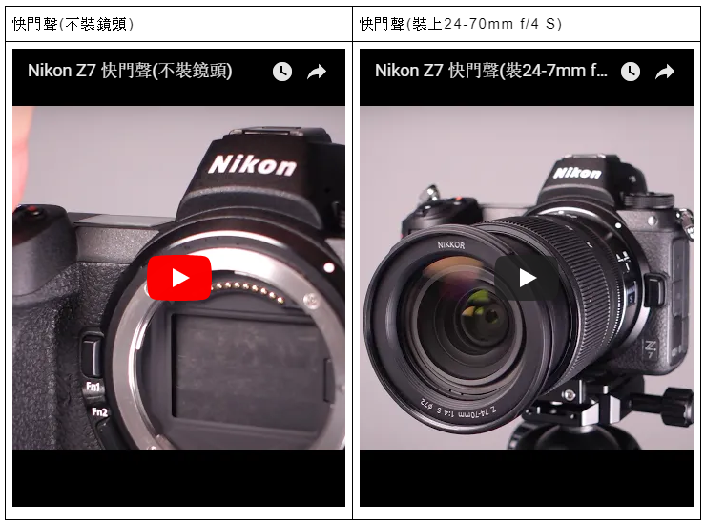
這是以9fps，也就是Z7最高的連拍速度的快門聲。以小編的感覺來說，快門的震動不大也不小，我目前用到過最輕的無反相機快門應該是Fujifilm X-H1，在稍微吵雜的地方就會完全不知道自己按了快門的那種。

This is 9fps mode, which is also the highest speed of Z7. From my feeling, the shutter vibration is medium, the lightest shutter I’ve used until now should be Fuji X-H1, under a noisier condition, you may not even know you’ve press the shutter.
如果你擔心Z7的快門震動會影響畫面，你有兩個方法可以減少或避免快門震動：
- 電子前簾快門，聲音較小。但最短快門時間會被限制在1/2000s，ISO最高25600
- 寧靜攝影(電子快門)，完全無聲，且不會有快門速度或ISO限制(RAW檔也可以維持14bit)
If you are concern about the vibration affect your photo, there is 2 ways to reduce it.
- Electronic Front Curtain shutter, slightly lower noise. But the shutter speed is limit to 1/2000s and ISO 25600.
- Use electronic shutter, completely silent, and no limitation on shutter speed or ISO. (RAW remain 14bit)

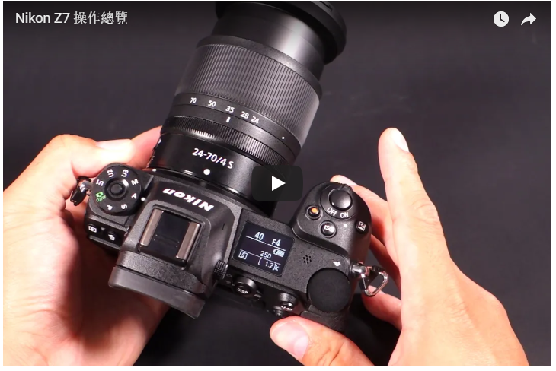
Function overview, video is self explanatory.
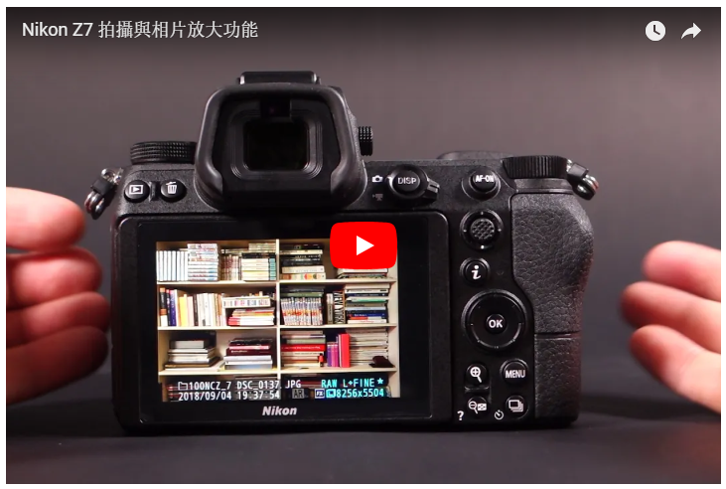
Shooting and Photo review zoom function.
拜EXPEED 6處理器所賜，相片的縮放已經能夠做到毫無延遲、立即的程度，放大後相片與相片間的切換會有一點點lag，但可以接受。
Thanks to speed of Expeed 6, the zooming of the photo is almost no lag, very instant. But swiping to next photo in zoom in stage will have some lag, still acceptable.
至於照片單張單張的大幅度移動，速度還是沒有很快，我是說像Fujifilm X-T2或Olympus E-M1II那種毫無延遲到令人吒舌的程度，Z7還做不到，不過X-T或E-M1 MarkII可沒有4570萬畫素，所以我不太有意見。而且在選單裡面一次可以選擇跳10張或50張，所以要快還是可以很快速瀏覽。
The photo scrolling still not very fast, unlike Fuji X-T2 or Oly E-M1II, they are instant. But those camera didn’t have 45 Megapixel, so I have no comment. You can view by 10 or 50 photos in the menu, so navigating can be quite fast.

Burst Buffer
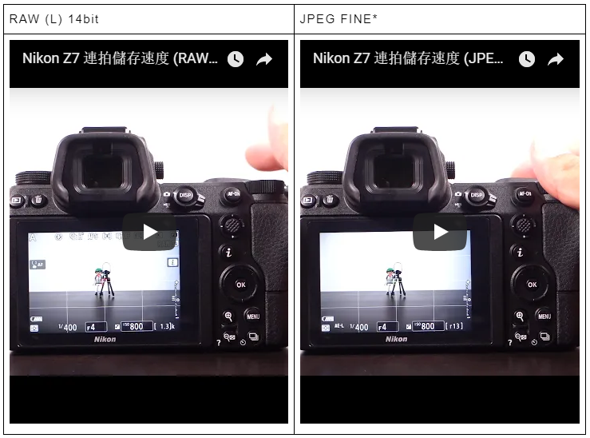
雖然Z7的官方數據是最高每秒9張，但這是有條件限制的。每秒9張的意思是在固定第一張測光的條件下使用連拍，如果你要完整AF+AE的話，會變成5.5張。這大概大家多多少少都知道。
Stating the fact that the Z7 only able to provide 5.5fps burst mode if AF + AE required.
還有一個更細節的內容，是如果你選14bit RAW的最高畫質，連拍速度會降為8fps。只有在12 bit RAW才有辦法達到9fps。
Burst mode will limit to 8fps if 14bit raw is selected, only 12 bit raw able to provide 9fps.
然後新推出的電池手把裝上後，將不會提升連拍速度，僅僅是續航力提升為兩倍。No boost mode after battery grip provided, only extension of battery life.

 | 卡彈前連拍張數 (Shots burst until buffer) | 平均相片尺寸 (Average file size) | 總大小 (Total Size) | 總儲存時間(含拍攝) (Time to save)
RAW (L)  14bit無壓縮 | 18 | 87.2MB | 1.57G | 18秒
JPEG (L) FINE* | 24 | 19.1MB | 458.4MB | 22秒
這個為什麼458MB的儲存時間會比1.57G來得長我實在搞不懂...
Why the storage of 458MB is longer than 1.57G is beyond my reasoning.

Autofocus on 2 new lenses
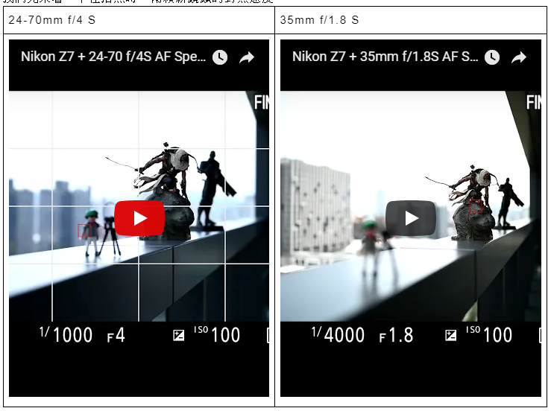
24-70mm f/4 S與35mm f/1.8 S的對焦速度都相當棒，就是高階鏡頭的對焦能力表現，對焦毫不拖泥帶水。
24-70mm F/4S and 35mm F1.8S focus greatly, up to expectation of high end glasses, no lagging.

Face Detection
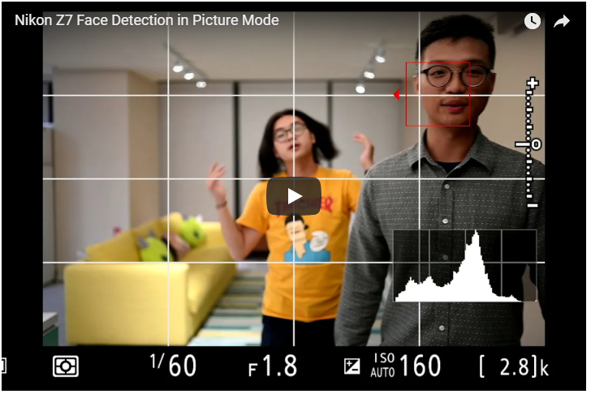
因為Sony有推出超好用的[眼控對焦]，所以好多網友也關心Z7有沒有類似的功能。
答案是沒有，沒有眼控，只有臉控。Only face detection and no eye detection
(有點可惜，隔壁棚的Canon EOS R有眼控，但只限於單次對焦，CN兩家請加油)
Nikon稱這個功能叫做[自動區域AF臉部偵測]，只有在[自動區域AF](也就是全畫面)中可以使用。當畫面中出現人臉時，Z7就會自動去框出人臉，但你還是必須要自己使用AF-ON或半快門來對焦。下面這則影片是我請同事在拍照模式下錄製：
Nikon has this function call auto zone AF face detection, only in auto zone AF able to turn on. Whenever there is face in the frame, Z7 will frame up the face, but you need to half press shutter or press AF-On to focus.
- 00:00~00:10：當畫面中出現超過1個人以上時，人臉框的旁邊就會出現小三角，告訴你可以使用方向鍵去選擇其他人。
- 00:13之後：持續按著AF-ON，做連續自動對焦。對焦時框框會呈現紅色。
- 00:20：即使人臉背對，對焦框依然會在人頭上。
- 00:30~00:35：即使用另外一個人臉干擾，對焦框依然會抓住原本的人臉。
- 00:40：頭髮遮住臉會影響臉部辨識。
- 00:50：過大面積的物體遮擋依然會影響臉部辨識
- 01:24：要用頭髮騙過臉部對焦也不是那麼容易的事，你必須要遮住很多。
在使用前我一直以為493點可以像官方圖這樣覆蓋滿整個畫面，其實實際運作時你永遠只會看得見一個點。開啟人臉自動對焦時也會把人臉框住，上圖肯定是自己選的對焦位置。
我們來看看影片的臉部辨識對焦：
影片的臉部辨識我設定成AF-F，就讓相機自己去對。邏輯上是與拍照時一樣，但因為影片對焦就不會像照片這麼快速直接，對焦起來會比較順暢一點。
以人臉對焦來說，Z7的技術算是很聰明的，人臉辨識的方式跟我理想中的差不多。我很喜歡轉頭時對焦框依然鎖定在頭部的設計，或者是移動時被其他人臉干擾時，依然會抓在原先的人臉上。整體的作動方式都相當合理。是很聰明的辨識系統。
Face detection for video, I like the way Nikon has the focus on face even though the people turn away, or obstruct by other people, it still maintain the focus on the original subject. Overall the system is quite intelligent.

Focus in the dark
Z7可以做到全對焦點都擁有-4EV的對焦能力。這次小編終於認真的對待這件事情，剛好有機會遇到Nikon新加坡的人，抓著他死命地問，他傳了一個維基百科的曝光值表給我：
Z7 claimed to focus in -4EV. The editor take the claim seriously, so it hold on the Nikon Singapore Representative and keep pressing on this matter, he sent the editor the table below for the definition.
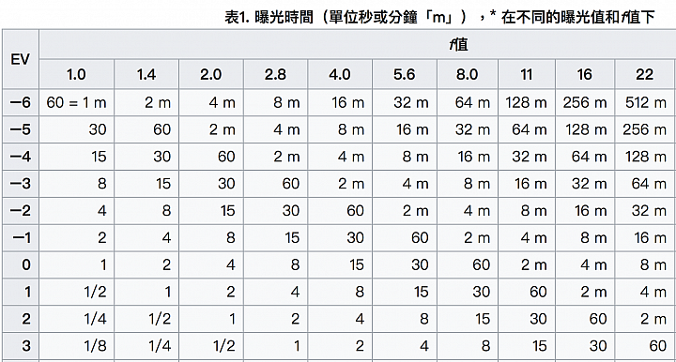
-4EV代表的意思是，在光圈f/2.0、ISO100的條件下，曝光時間1分鐘的亮度。稍微換算一下，意思就是：
What -4EV means is, in Aperture f/2.0, ISO 100 condition, the shutter speed has to maintain for 1 minute, so the iteration will be as below. Conclusion is very dar.
- ISO12800 f/2 1/2s,
- ISO25600 f/2 1/4s,
- ISO51200 f/2 1/8s, 總之就是很暗的意思
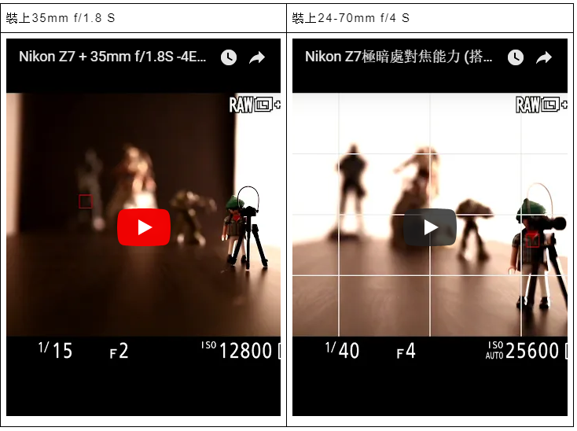
各位要先知道，進光量會直接影響暗部對焦能力，f/1.8光圈的鏡頭就是能夠比f/4的光圈獲得更多亮度。我們這次拿到的35mm f/1.8 S與24-70mm f/4 S，各位可以比較一下這兩顆鏡頭在極暗處的對焦能力。附帶一提，差距非常大，是「對得到」跟「連看都看不到」這樣的差距。
Please bear in mind, the amount of light though to the lens will affect the focus capability, F1.8 aperture will focus better than F/4 due to amount of light. Let’s try out both 24-70 and 35mm S lenses, you can compare the focus in dark environment.
敝公司的攝影棚把門關起來、燈全關，光靠門縫的光線，就差不多是-4EV的亮度。如果不開啟[低光源AF]功能的話，幾乎是對不到焦的。而開啟後較容易看見，也對得到焦，基本上看得到就對得到，但對焦速度會變的很慢。建議如果可以的話最好還是開啟對焦輔助燈。我想上述的物體都不會發光也是一個困難的點，如果你拍的東西會發光，像是銀河或極光的話，可能成功率或速度會高些。
-4EV is roughly like you shut the door, turned off all light and only let the light come through the slit of the door. If the function of low light AF is turn off, almost unable to focus. Easier to focus once turn on, and able to catch on it. Basically if you can see then you can focus, even though it will be slow. Suggest to turn on AF assist light, for non reflective items, it will be quite hard, but if you take photo of star, it should be higher chance of success.

Stabilization test
要在4570萬畫素裁切到1:1的情況下還能夠有維持穩定的畫面，老實說非常困難。其實我一點也不期待1/30s以下的表現，但1/20s秒的狀況還不錯，以小編的標準來說有9成。但1/10s與1/5s的成功率就驟降，變成40%。但就算是1/5秒也還不到5級手震補償的效果。
Crop to 1:1 under 45 megapixel and able to maintain the stability is honestly very hard. I don’t expect any result slower than 1/30s, but 1/20s is not bad. According to my own standard, there is 90% of success. the success rate of 1/10 and 1/5 drops dramatically, around 40%. Even up to 1/5s, it hasn’t reach 5 stops compensation.
小編一直認為這個5級並不是要你真的去測試在安全快門的極限(70mm的安全快門約為1/2.5秒)，而是提高1/30s或1/60s的成功率。小編在測試時一直都是以1/60s或以上的快門速度在拍攝，因為依照過去經驗，3600萬畫素以上的相片實在很難不模糊，如果要獲得銳利不晃動的畫面，快門速度才是關鍵。
I don’t think 5 stops meaning you need to determine the safe shutter speed in extreme condition, but instead should increase the success rate for 70mm lens under 1/30s or 1/60s shutter speed. It is very hard not to cause blur in 36 megapixel and above, shutter speed still the key factor.

ISO test
各級感光度的部分，光線與過去都相同。然後這裡我拿D850來做個比較。兩台相機是在完全相同的位置拍攝。但鏡頭可能有放大倍率的差異，所以構圖上來說不太相同。兩台相機的Picture Control設定都是Standard。
The test simulate under the same condition as previous. Comparing to D850, both set to picture control, standard.
我們發現D850的畫面比較清晰一些，同樣是70mm，24-70mm f/2.8G VR拍的畫面會比較大。在雜訊的部分，D850的表現會來的好一點點。兩台相機的雜訊抑制都是Normal，在ISO3200以上就比較容易看得出來，D850的畫面硬是要更乾淨一點。但Z7其實表現也相當不簡單。
D850 appear to produce clearer result, under 70mm. D850 seems producing slightly better result in terms of noise. Both camera set to normal NR, D850 just appear to be better under ISO 3200 but Z7 already remarkable. You may download the JPEG and RAW sample in the link.

Final thought
在機身的設計與操作手感上，所有的Nikon數位單眼用戶都一定能夠感受到完全相同的操作邏輯，以及一貫明確直覺的選單介面。你會需要花一點時間去適應新的按鍵位置，但很快就會上手。同時也保有Nikon不肯妥協的機身扎實感，這些都能在Z7上面體會，我想每一位Nikon用戶都會有如此感受。
The handling, feeling and ergonomics gives the same impression for all Nikon DSLR user, including the menu. You will mostly spend some time to accommodate the button location, but will feel at home very fast. At the same time, the ruggedness and robustness remain the same in Z7.
Z7的對焦能力上，使用Z接環鏡頭追焦的表現不錯，但我認為要等到望遠鏡頭推出後才能夠比較容易看得出真正實力。而單次自動對焦速度，在使用Z接環鏡頭的成果也滿好的。但我總是覺得，常常有時候在物體的對比度不夠強時—例如遠處迷濛的山景，或天空中的雲朵—Z7就常會猶豫，需要多試幾次才能夠正確合焦。暗部對焦的部分也能夠在相當陰暗的地方成功合焦，如果真的非常暗，可以開啟低光源AF來提高成功率。但總體來說要追上D850那種毫不拖泥帶水、對到哪就是哪、幾乎不會來回確認的對焦可靠度，我想還有一段距離要走。
In terms of focus capability, using Z mount native lens to continuous focus is quite good, but the verdict remain to be seen until long zoom is available. The result of single focus is very good. But I felt that, whenever the contrast of the subject is low, example the blurry mountain in far sight, or cloud in the sky, Z7 tends to hesitate, need to try multiple time to focus. For dark focus, it is quite positive on the result, you may even turn on AF assist light if the environment is really really dark. But if comparing to D850, non hesitant, fast, pin point feedback, Z7 still has a long distance to go.
但對於人臉追蹤辨識的能力來說，辨識的表現非常好，它知道應該抓在哪個人的臉上，也會在人物轉頭時繼續追蹤頭部，失去臉部時也會自動去追其他張臉，這點倒是做得很聰明。
For face detection, the detection is very good, it knows where it shall focus and keep track of it. Losing detection of one face will swap the focus frame to another subject face, this is quite clever.
錄影的部分，全幅不裁切的4:2:2 10bit加上N Log的規格，肯定會吸引到不少錄影攝影師的目光，不過如果你想要盡可能的獲得最佳畫質，建議可以選擇以超取樣讀取的Z6。同時Z系列自帶有機身手震補償+電子防震，對於拍影片的朋友來說也是一項優勢。
For video, non crop 4:2:2 10bit plus N-Log will certainly attract many videographer, but Z6 may be a better choice if the video quality is what you after. IBIS is also a plus for video.
就我個人而言，Z7吸引我的就是Live View的自動對焦能力。因為過去Nikon數位單眼的Live View幾乎沒有變化，對焦速度不僅慢，對焦成功率低、暗部的對焦能力也差、雜訊又多，基本上可以說是沒什麼優點的功能。每次在攝影棚拍攝時，我想用Live View看光線的位置，Live View總會讓我覺得浪費時間。有了Z7可以直接解決這個問題，而且畫面還可以直接用USB或HDMI送到螢幕上，我就可以邊調整拍攝物邊看實際畫面，這是最吸引我的地方。
For me personally, Z7 attract me the most is auto focus under Live View. The reason being previous Nikon has no benefit at all in this regard, Z7 will be very helpful in this regard especially in studio shot which can see the focus on live view or through HDMI, this is very attractive.
我會說Z7能夠跟D850平起平坐嗎？我並不這麼認為。D850已經是非常成熟的產品，你甚至可以說它是數位單眼的頂峰，它的一切都做到極專業，我想Z7唯一明顯贏過D850的，只有體積、重量與Live View的對焦速度。所以我覺得如果你已經有一台D850，而且是已經很習慣拿它來工作的，其實我想Z7的能耐不容易吸引到你的目光。
I don’t think Z7 is on par with D850. D850 is very mature product, you can even say it is the peak of DSLR, very professional tool, the only thing Z7 wins is the size, weight and live view focus capability. If you already have a D850, and used to it in your working environment, Z7 wont be very attractive for your.
但如果你想要在專業功能之餘，同時也能夠有輕巧的體積，或者是你需要一台能夠陪你上山下海的全幅機種，但又希望能夠盡可能的減少背包或行李箱裡的重量；或者是你過去就是Nikon用戶，想要換一台輕便的機種，又同時想要繼續使用過去習慣的鏡頭，那Z7真的是不二之選。
But if you want lightweight and smaller body size other than those professional function, or you need one camera you can bring to mountain and down to sea, and hope to reduce your package weight; Or if you are previous Nikon user, and want something lighter, and keep using what you have before, then Z7 is your only choice.
綜合本篇文章所有實測，小編認為Z7繼承了Nikon的優良基因，以光學技術為起點打造新接環，獲得輕巧體積與頂尖畫質，同時也延續了Nikon的操作性。初步使用約一週的時間，Z7會讓我持續想要再發掘它的能耐。屆時台灣正式發表後，建議各位去現場試玩實機，體驗Nikon對於下個100年的想望。
In total, Z7 inherited the plus of Nikon, building a new mount from the goal of optical excellent, and getting top image quality and small size, while maintaining Nikon ergonomics. After one week of testing, Z7 let me wants to keep on exploring the potential. Until then, hope you all may test it out in showroom, to experience what Nikon wants to achieve for the next 100 years.
Nikon Z7表現不錯的地方 (Pros)
● 翻轉螢幕 (tilty screen)
● 臉部追蹤辨識表現優異 (Good face detection AF)
● 搭載5軸5級防手震，提高照片成功率，老鏡也可受惠 (5 axis 5 stops IBIS)
● Z接環鏡頭畫質優異 (Z mount lens excellent image quality)
● 操作快速，有許多自訂功能 (Fast functionality operation, many customisation)
● 目前唯一的一台全幅錄影不裁切，同時擁有4:2:2 10bit畫質 (The only full frame camera giving non-crop, 4:2:2 10 bit video quality)
● N Log有13檔動態範圍 (N-Log has 13 stops of dynamic range)
● 電池續航力實測約1000張左右，與官方數據330相去甚遠 (Batter life of around 1000 shots, far better than official 330 CIPA result)
Nikon Z7需要加強的地方 (Cons)
○ 連拍緩衝區不足，張數最多在20張左右 (Small buffer size)
○ 物體對比不強時對焦不容易合焦 (Hard to lock on for low contrast subject)
○ 沒有眼部自動對焦 (No eye AF)

